Lab: Monitoring Data by Email (Sumo Logic)
I created an email monitoring alert so the system can automatically send me updates at a scheduled time, even when I am not actively checking the dashboard.
This is important because it allows continuous monitoring without needing to stay logged in or watch the data manually. The alert gives me a full report of the current status, including any unusual activity or changes in trends.
It also helps in early detection of errors, performance issues, or security risks, so I can respond quickly. Email alerts are useful for tracking system health, monitoring traffic behaviour, and staying informed about important events in the environment. Most importantly, they save time and make sure that nothing important is missed during off-hours.
As an example, I selected Apache from the library on the left side of the panel. Then I opened Apps and chose Apache. The main screen displayed several dashboards.
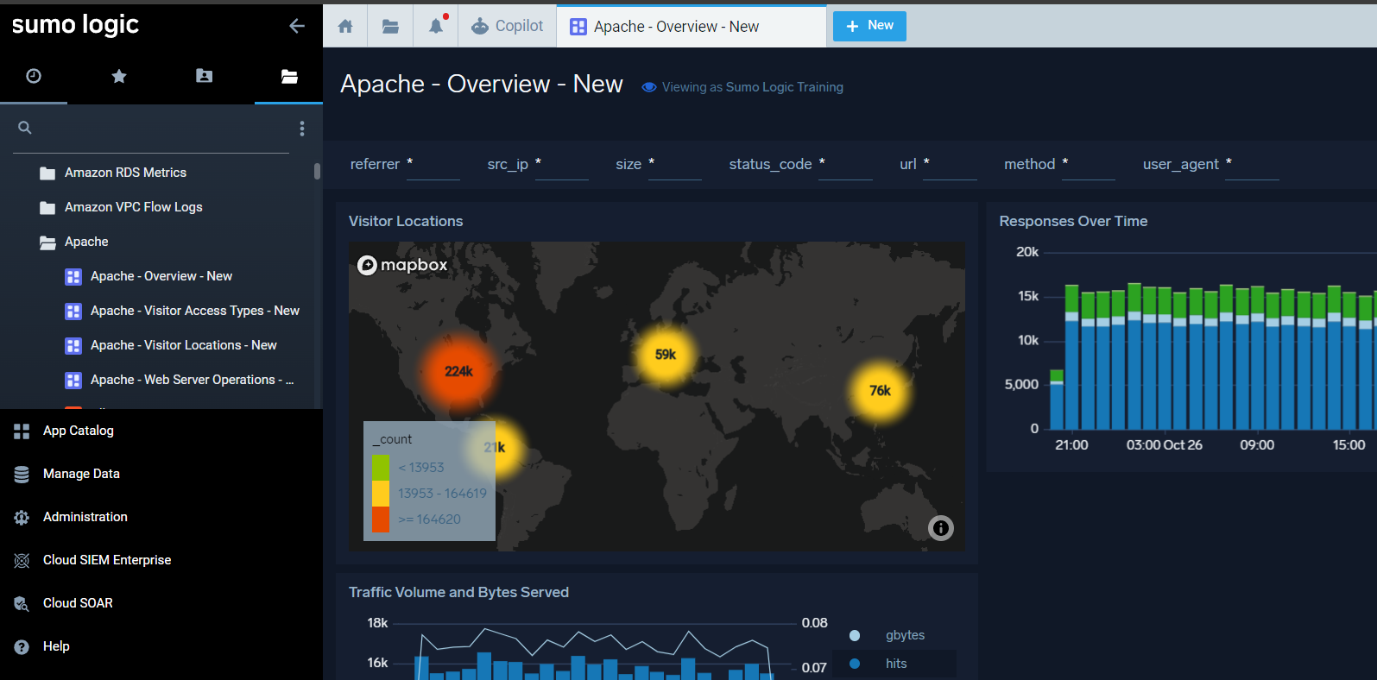
After that, I clicked the three dots on the Visitor Location’s panel and selected Open in Log Search, which opened the log search in a new window.
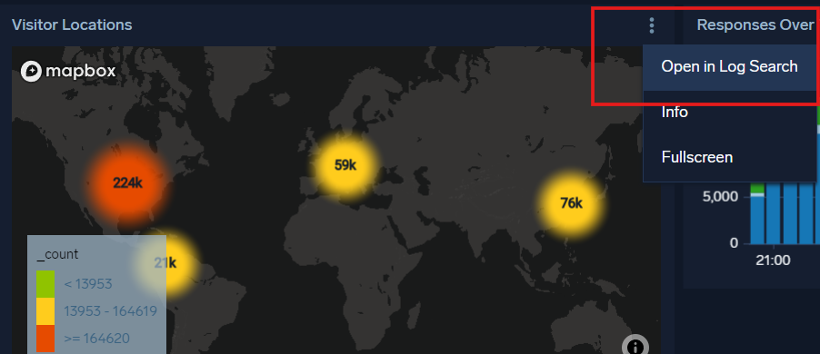

On the next window, I clicked the three dots on the right side, and several options appeared.
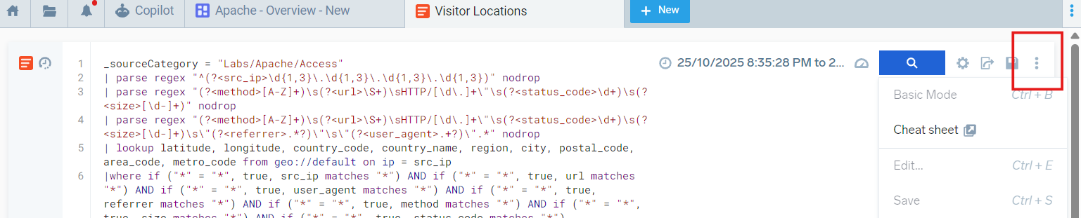
I selected Save As, and a small window opened.
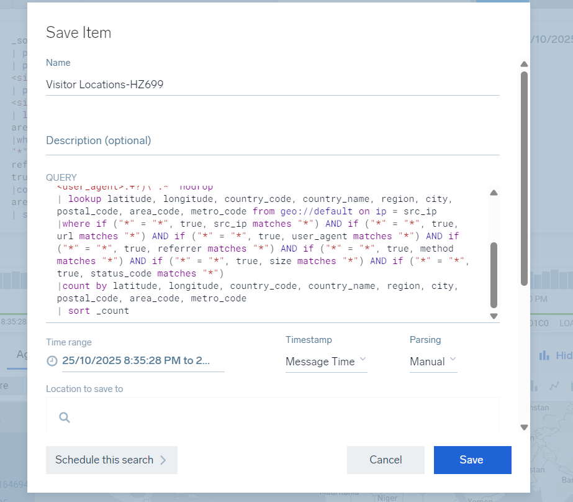
In the small window, you can save the search to your personal library by changing the name and description. The query is also shown, but it does not need any changes at this moment. There are also other important details about the Visitor’s Location.
At the bottom left of the window, there is a button called Schedule this search, and clicking it moves to the next small window.

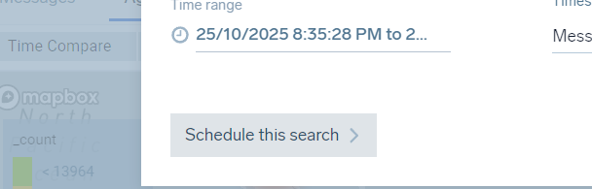
In this window, I selected the Run Frequency, which defined how often the monitoring data would be sent to me.
Then I added the email address, and the window displayed all the necessary information that would be sent to my inbox.
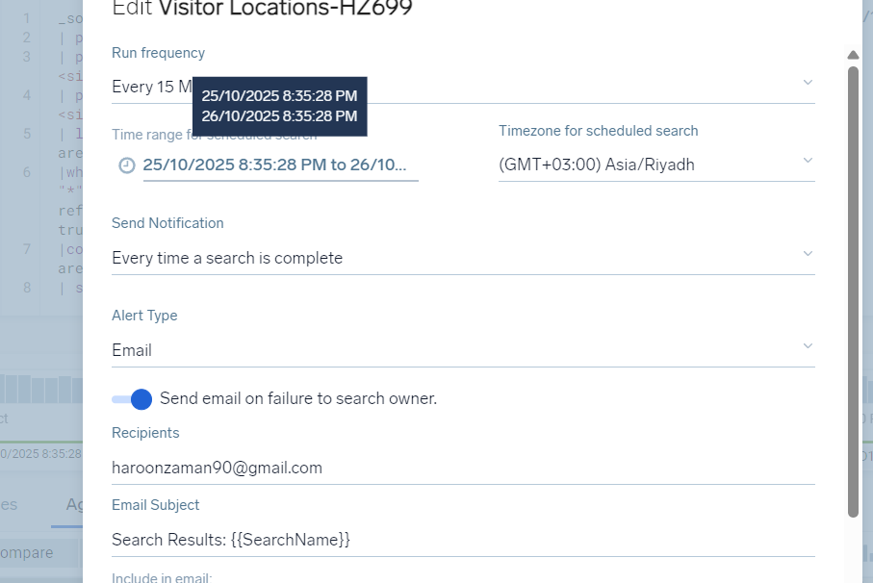
After selecting my preferred options in that window, I clicked Save, and it was added to my personal library.

As I had selected a run frequency of 15 minutes for my lab, the system started sending me the monitoring emails after the set time passed, as shown in the screenshots.
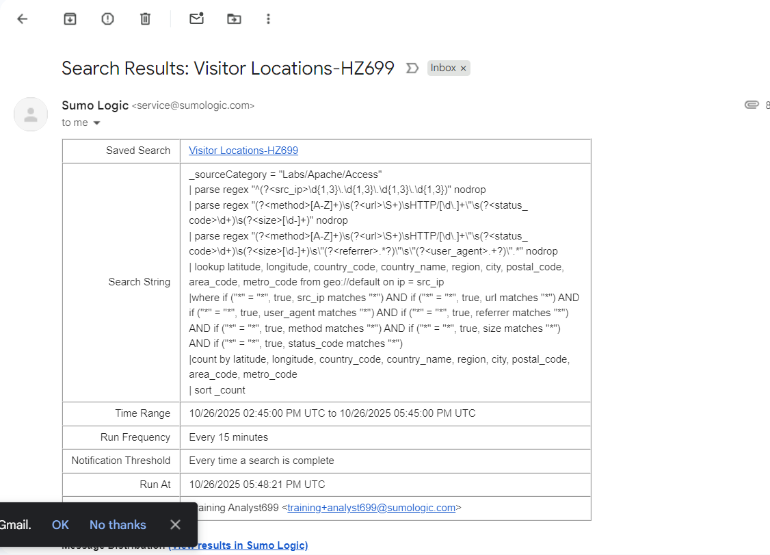
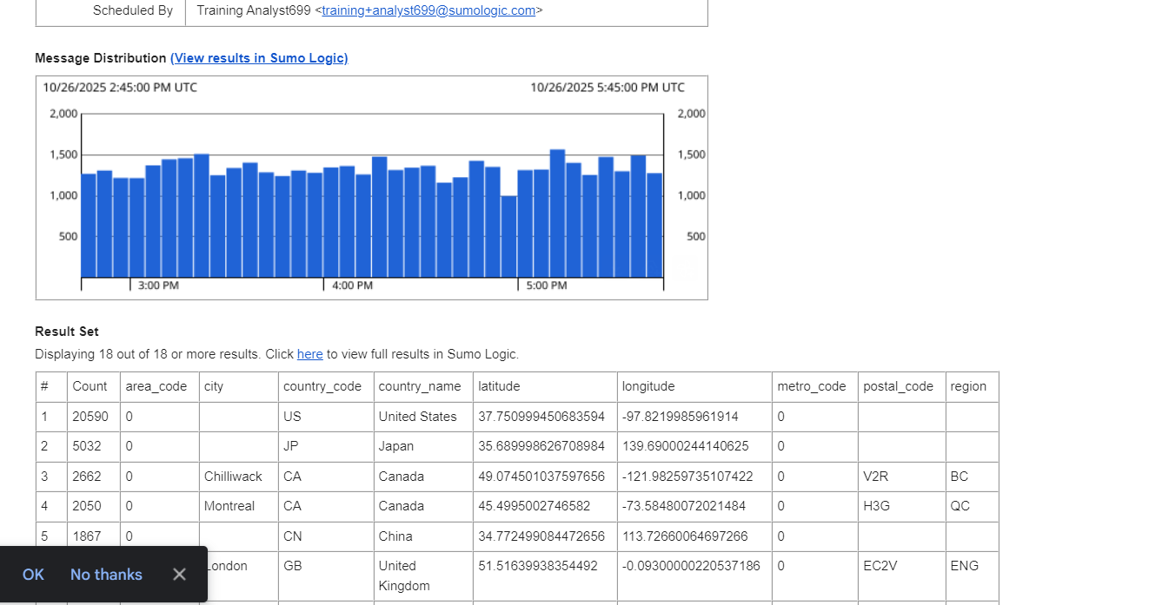
A CSV file with the same data was also attached.
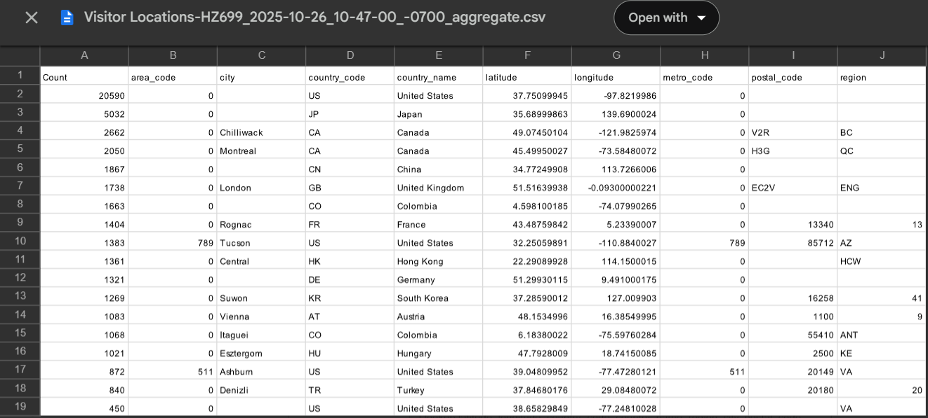
After saving, I could also edit the schedule of that search.
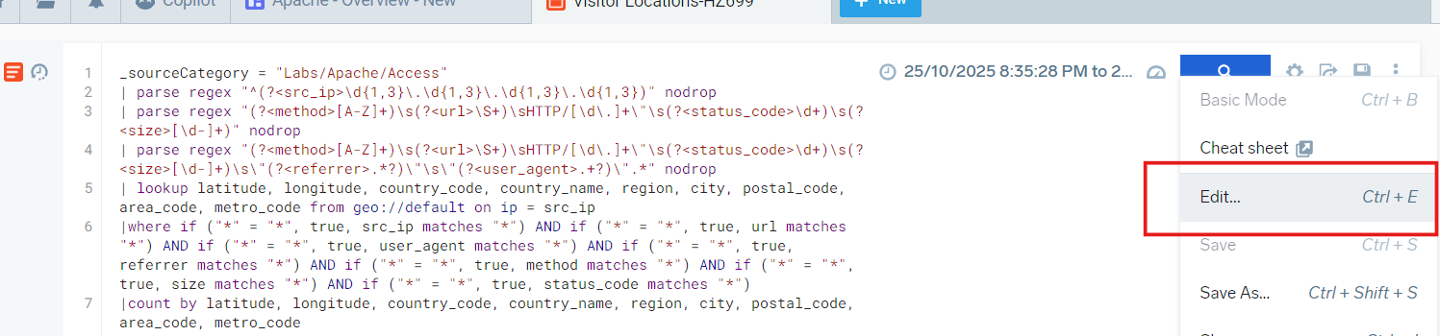
I stopped the email alerts by following the same path: Save As → opens a small window → Run Frequency → Never → clicked Save, and the alerts were stopped.
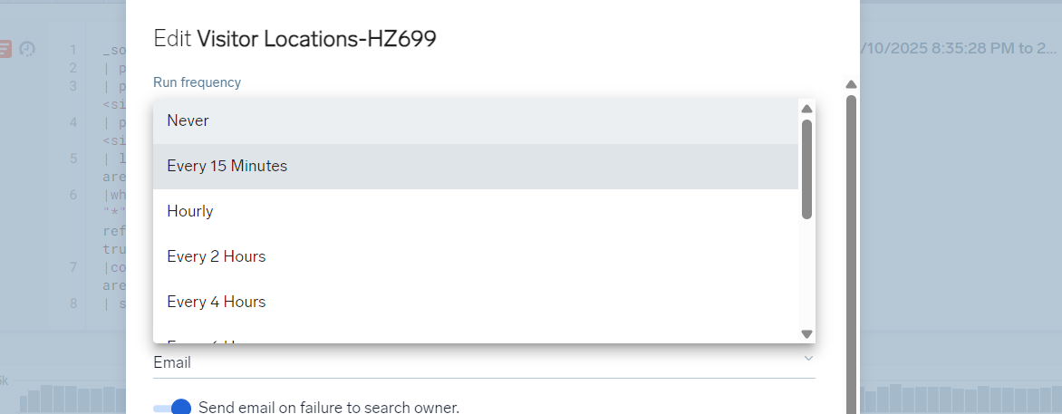

Conclusion
In this lab, I learned how to create and manage email monitoring alerts for system data. I understood how to select a dashboard, open a search, save it to my personal library, and schedule it to run automatically. This process is important because it allows continuous monitoring even when I am not actively checking the system. I also learned how to customize the alert frequency, view the data that will be sent, and stop the alerts when needed. Overall, this lab helped me understand how automated alerts can save time, improve system oversight, and ensure I am always informed about important events and trends in the data.

